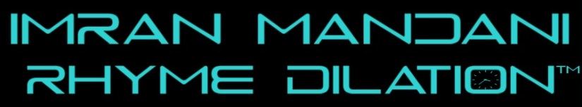
Imran Mandani’s first single, “You Should Dance”, is a blend of Hip Hop and EDM music for the Nightclubs. The song makes the listener do what the title says. Unlike typical Club music with repetitive and raunchy lyrics, the song tells a story; guy meets girl and tactfully persuades her to dance. The track caters to Hip Hop lyrically while melodically having an Electro-Pop feel. Diving further, Imran released his second single, “Beneath the Ocean Tide”. Starting off with a piano solo, a rising vocal inflection lifts the melody into a fast tempo song. The poetic lyrics tell the tale of two kindred spirits who connect on a spiritual and emotional level but experience miscommunication and relationship setbacks. The song tastefully switches gear several times with its ear candy: unexpected fast rapping and a unique Techno ending. In time for late spring showers, Imran’s third single “Sunshine through Rain” is a chorus heavy Pop and Electronica song with Psychedelic Trance in the bridge. The lyrics are romantic and spiritually poetic; a man metaphorically lost at sea is able to come back to bay through the help of a special woman whose love is the guiding force in his life. Imran recorded actual thunder and rain for the song’s intro. A legendary House musician will be the back-up singer on the song’s official remix. All three songs are off Imran Mandani’s debut album, Abstract Brown, a work in progress.
Rhyme Dilation is the name of Imran Mandani’s Hip Hop brand. It is a pun to Albert Einstein’s Time Dilation. While Time Dilation explains how time slows down at light speed, Rhyme Dilation is how time drifts by differently when an artist is in the “flow”. The philosophy continues with how music has a time travel effect: a four minute song can affect people's emotions for years. The brand draws inspiration from Albert Einstein’s legacy. Einstein’s struggle to prove himself in the scientific community without merit is analogous to a musician’s struggle to make it in the industry. Rhyme Dilation encourages listeners to follow their passions, give importance to education and to unconventional thinking. "Don't keep it real, be ethereal (be the real)” is the motto: one should not “keep it real” with “ego” or “street cred” but be “The Real”, or connect with the Divine aspect within oneself. Rhyme Dilation is about dilating, or expanding Hip Hop, to incorporate other styles of music. The music melodically has a "Top 40" feel but lyrically has poetic and spiritual subtly. The music incorporates elements from Hip Hop, Trance, Electronica, Synth Pop, Psychedelic, Electro Pop, Trip Hop, EDM, Hip House, Dream Pop, Indietronica, and EDM. Rhyme Dilation also includes Imran Mandani’s merchandise brands called Ensemble, Raju Ensemble and Rani Ensemble with the slogans "Orchestrate your Life" and "Life is a symphony, be in tune with it”. Rhyme Dilation and the clothing brands are incorporated and copyrighted brands under Trademark.
Contact Tracks

Website: www.RhymeDilation.com “You Should Dance”
Emails: www.RhymeDilation.com/email “Beneath the Ocean Tide”
Press kit: www.RhymeDilation.com/presskit “Sunshine through Rain”

Accolades

2013 Microsoft Surface Remix Competition Winner November 2013
2014 Unsigned Only Competition, Semi-Finalist July 10, 2014
2014 Song of the Year Competition Semi-Finalist July 17, 2014
Wu Tang Clan Management Team Member August 1, 2014

